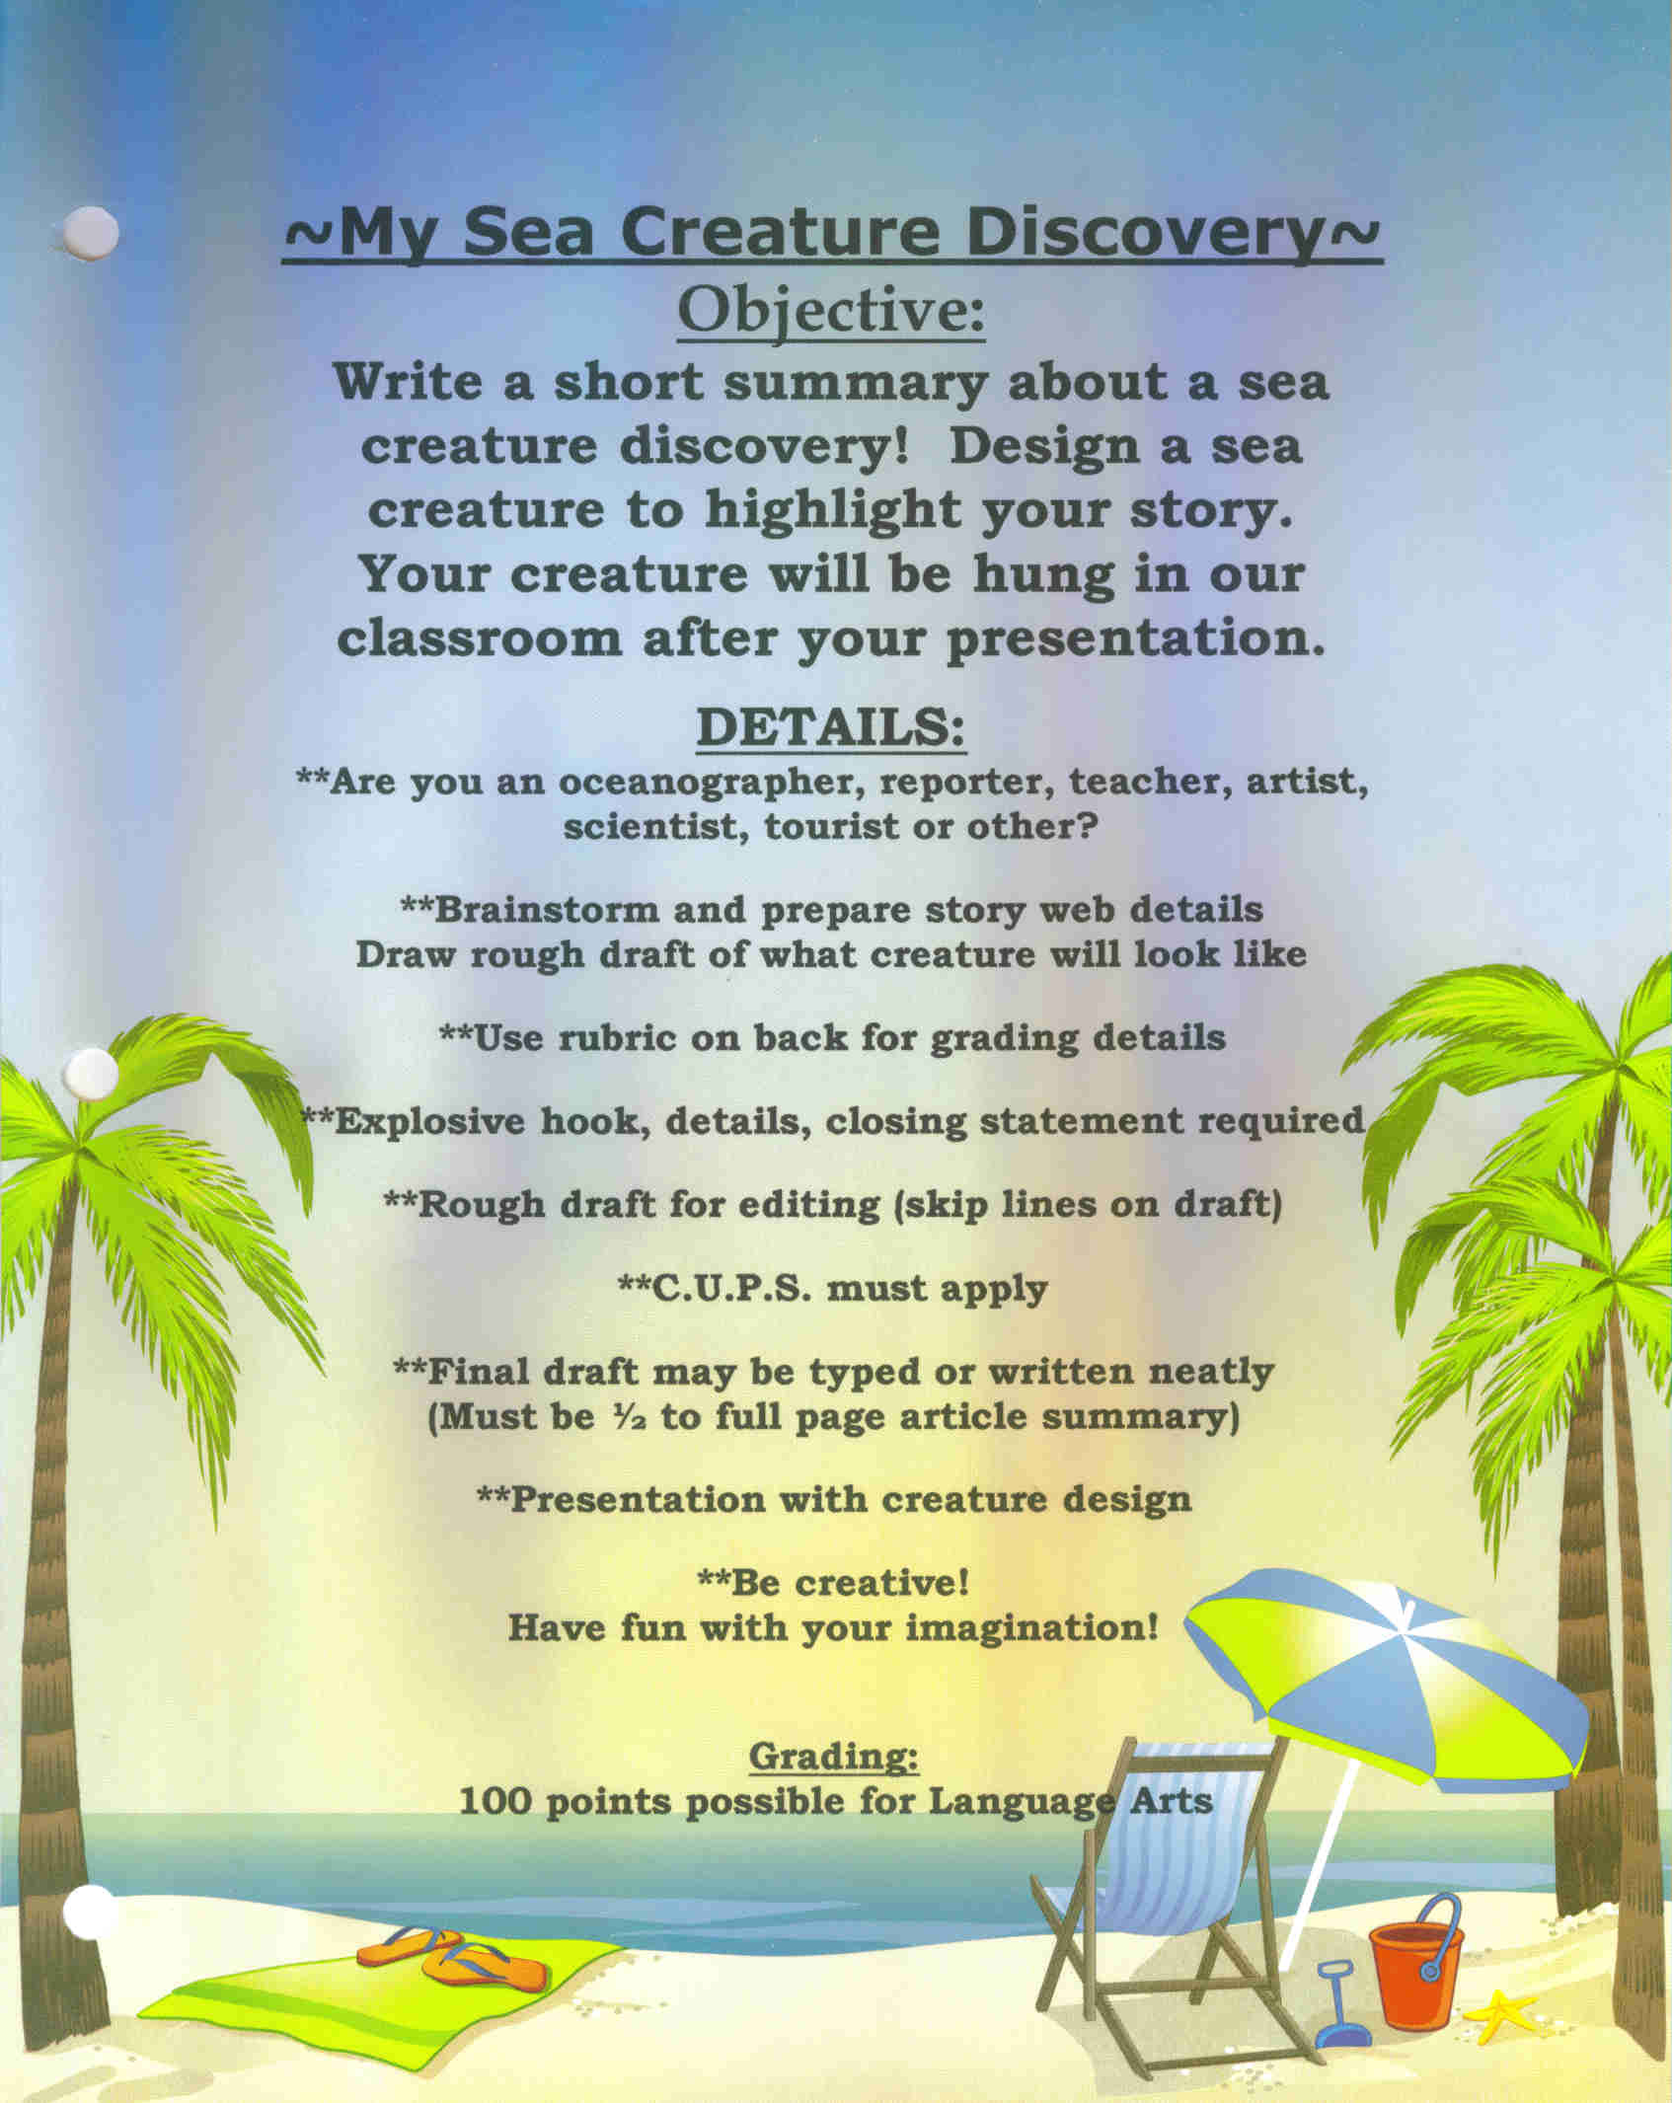
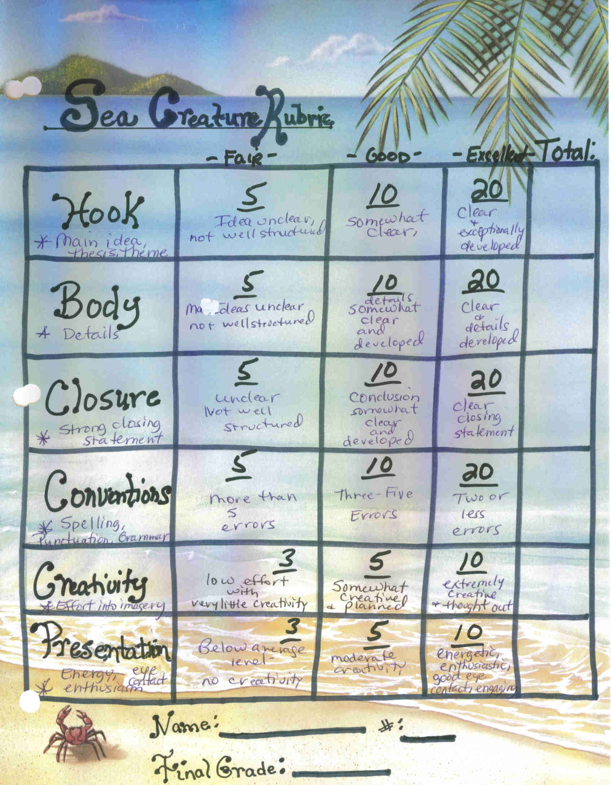
Professional Growth/Student Learning Evidence #2

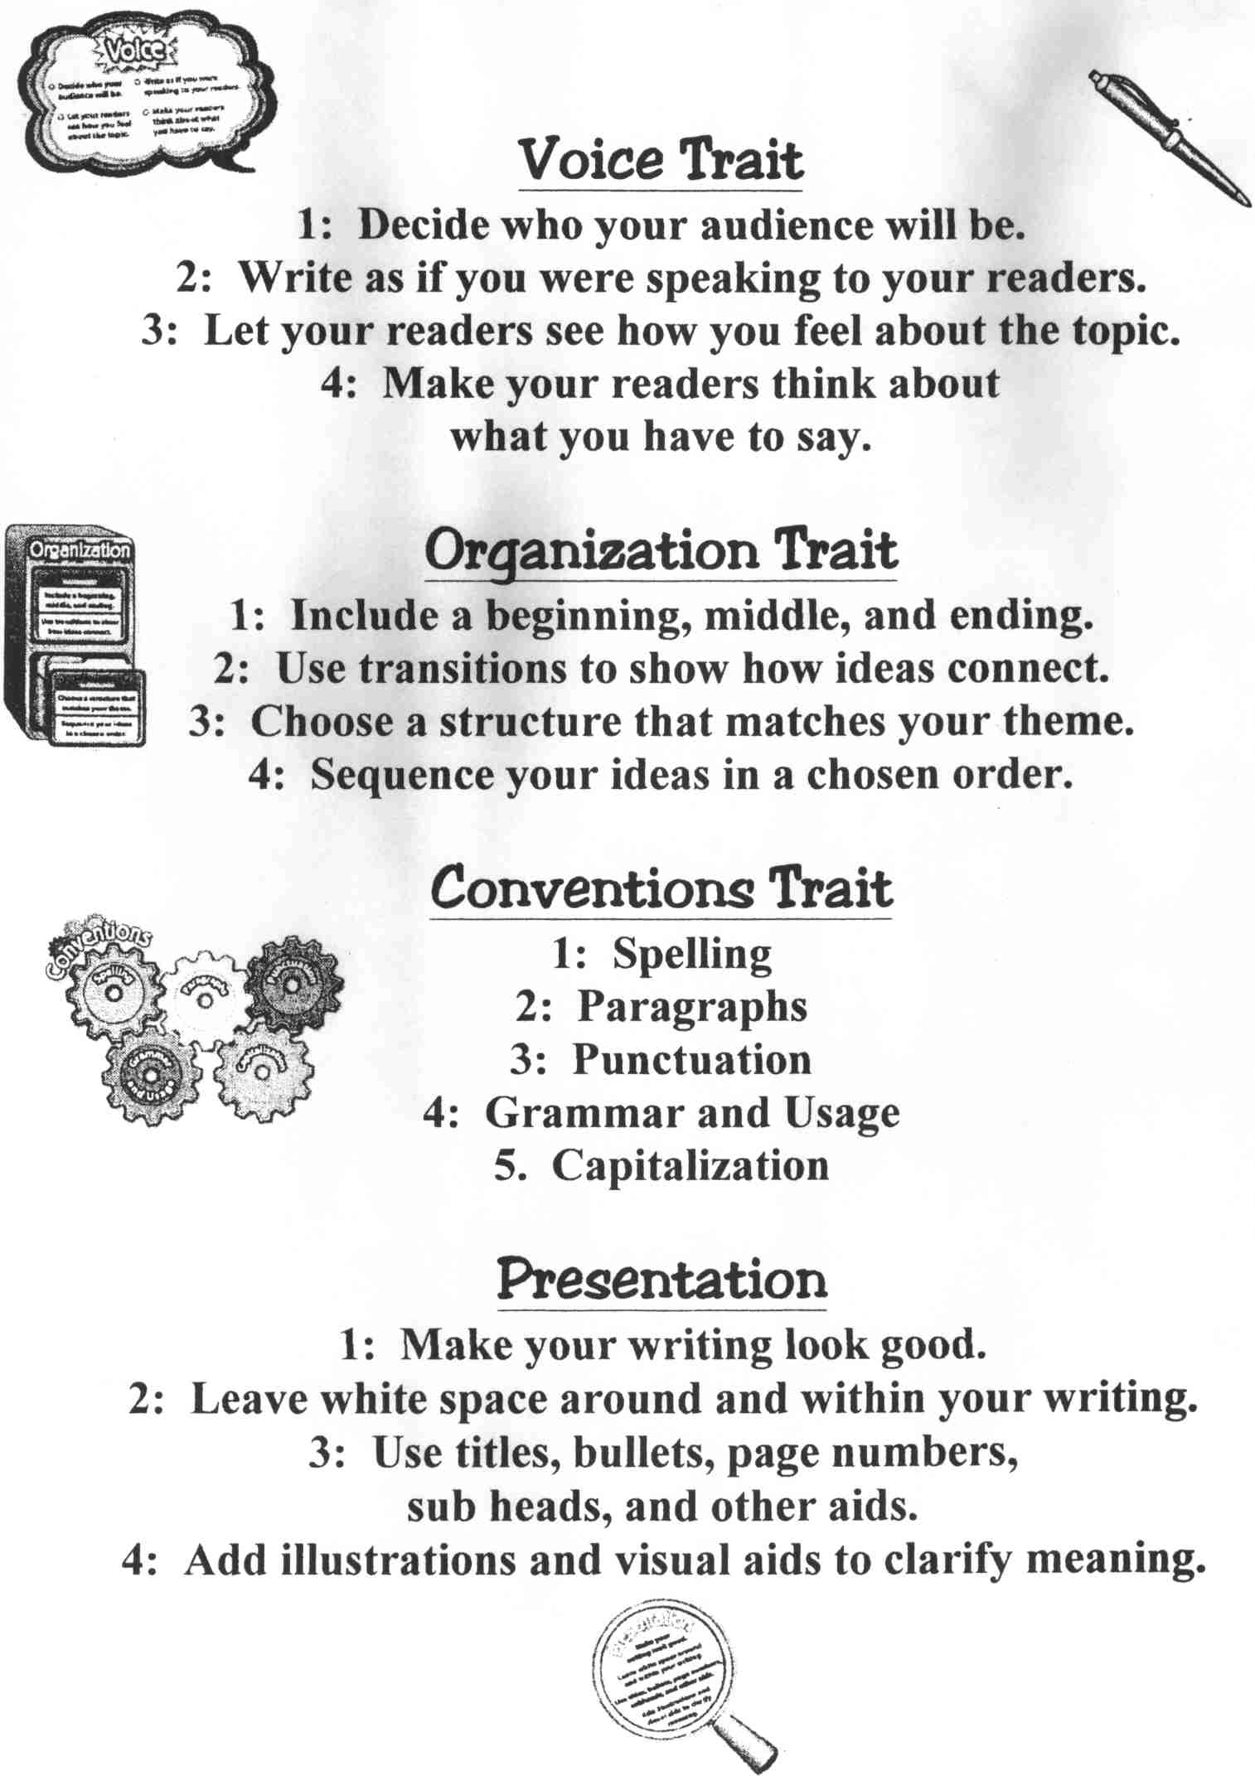


I was in Mexico, in the pool, with the beaming sun shining on me. I could hear the beautiful, brilliant, dazzling waves crashing against the shore. My brother Chandler was down on the beach. All of a sudden I hear the word “wow.” It was Chan. He found a slimy, slippery jellyfish. He ran up from the beach and showed me. I said, “Wow! That is so awesome.” Then, he put it up on the counter top by the entertainment center. Chandler was trying to be funny and he almost touched it and he yelled “ow, ow!” I said, “Oh my goodness are you okay” He said “I’m obviously not okay! I got stung by a jellyfish.” “What do you want me to do?” I exclaimed. Then he blurted out “Just kidding.” After, I slapped him gently and said “You scared me.” Chandler let the rubbery, ugly jellyfish go, back on the gigantic, clean, sparkling beach that God created for us!

By: Kennedy Nichole Hehr

